For Immediate Release
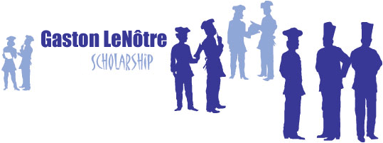
Contact: Marie LeNotre
(713) 358-5051
mlenotre@ciaml.com

A Valentine’s Night of Giving to the Gaston LeNotre Scholarship
Champagne & Chocolat Gala raises close to $250,000 for deserving culinary arts students

Houston, February 15, 2017 – Houston’s very own Marie LeNotre, Founder and President of the Gaston LeNotre Scholarship fund hosted a most fun and captivating evening to raise tuition scholarships for students in culinary arts programs. Tuesday, February 14, 2017 at the River Oaks Country Club, two hundred Houston’s philanthropic leaders wined, dined, danced the night away to live music performed by Bubba and Greg and enthusiastically participated in the live and silent auction. The gala was a cocktail red-tie Parisian-themed affair filled with elegance, romance and philanthropy; featuring champagne reception, epicurean dinner, the French Cancan Show, and a dessert buffet of endless petits-fours! Party guests enjoyed more than 1,000 chocolates, 500 macarons, 400 pastries, and 25 dancers-and-heart centerpieces made out of delicate pastillage.

Powerhouse gala committee included Honorary Chairs Anne & John Mendelsohn, Co-Chairs Kelli Cohen Fein and Mary Ann McKeithan. Margaret Alkek Williams received the 2017 Gaston LeNotre Scholarship Ambassador Award by 2016 Ambassador Award recipient Rolanette Lawrence and Marie LeNotre, for her exemplary philanthropic leadership and outstanding contributions to the scholarship fund. Guests enjoying the spectacular event included, Rolanette and Berdon Lawrence, Rosen Cullen, Martin Fein, David McKeithan, Alain LeNotre, Zane and Brady Carruth, Jane-Page and James Crump, Christina and Mark Hanson.

Since 2001, Gaston LeNotre Scholarship, a 501(c)(3) non-profit organization, has awarded close to $1million in tuition scholarship to deserving student to support high quality education in the Culinary Arts and assist students in securing a rewarding career in the Hospitality Industry. Tax ID 76-0673436. www.gastonlenotrescholarship.org

